Vanilla Cupcakes with Caramel Filling and Caramel Buttercream

Ingredients:
- Cupcakes:
  - 125ml flour
  - 80ml sugar
  - 2ml baking powder
  - Pinch of salt
  - 60ml butter, softened
  - 60ml milk
  - 1eggs
  - 2ml vanilla

- Salted Caramel Filling:
  - 60ml sugar
  - 8ml water
  - 8ml corn syrup
  - 30ml heavy cream
  - 8ml. butter
  - 1ml lemon juice
  - 1ml salt
- Salted Caramel Butter Cream:
  - 30ml butter, softened
  - 125-375ml sifted icing sugar
  - 8ml whipping cream
  - 1ml vanilla
  - Optional: 25-50ml cream cheese
  - Remainder of Salted Caramel Filling

Directions:
Cupcakes:
- Preheat oven to 375 degrees F.
- In a large bowl, whisk together flour, sugar, baking powder, and salt.
- Using an electric mixer on low speed, mix in butter, milk, eggs and vanilla.
- Beat on high until smooth – about 2 minutes.
- Spoon into 12 paper lined muffin cups. Fill ¾ full.
- Bake in the center of the oven for 18 minutes or until toothpick comes out clean.
Caramel Filling:
- Combine the sugar, water and corn syrup in a saucepan and stir with a wooden spoon on medium heat until sugar is dissolved.
- Cover and let cook for 3 minutes.
- Remove lid and head to medium-high. Bring to a boil.
- Cook until it becomes an amber color then remove from heat.
- Let sit 30 seconds before adding cream. Be careful as it will bubble up significantly.
- Mix carefully. Add butter, lemon juice and salt. Stir until combined.
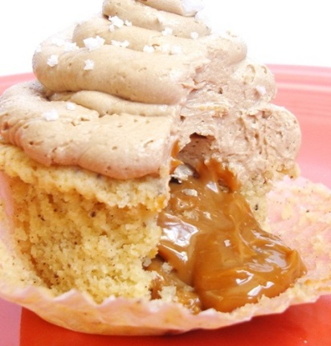
- Allow to cool until molasses like before filling cupcakes.
Icing:
- In a large bowl beat butter until light and fluffy.
- Alternately beat in sugar and cream. Beat in vanilla.
- Add remaining amount of caramel filling.

