TYPES OF PASTAS

ROUND ROD PASTAS
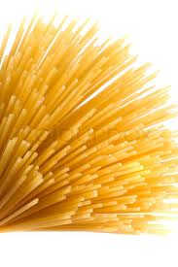 |  | Spaghetti | Most Common round-rod pasta
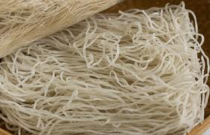 |  | Vermicelli  (Image is of rice vermicelli) | Thicker than spaghetti
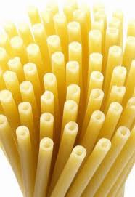 |  | Bucatini | Thick hollow spaghetti
RIBBON-CUT NOODLES
- Often rolled flat and then cut, this can be done by hand or mechanically.
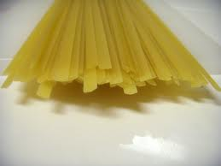 |  | Fettuccine | Approximately 6.5mm wide
 |  | Lasagne | Very wide noodles that often have fluted edges
 |  | Lasagnette | Narrower version of lasagna
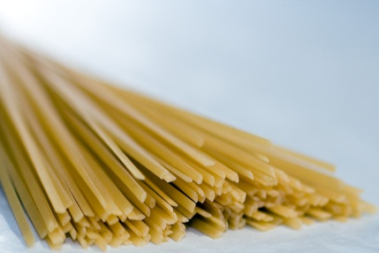 |  | Linguine | Flattened spaghetti
 |  | Pappardelle | Thick flat ribbon
SHORT EXTRUDED PASTA
 |  | Fusilli | Three-edged spiral, usually in mixed colours
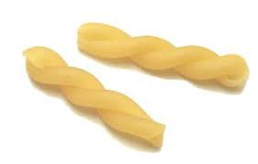 |  | Gemelli | A single S-shaped strand of pasta twisted in a loose spiral
 |  | Manicotti | Large stuffable ridged tubes
 |  | Penne | Medium length tubes with ridges, cut diagonally on both sides
DECORATIVE SHAPES
 | Farfalloni | Larger Bow ties
 | Fiori | Shaped like a flower
 | Radiatori | Shaped like a radiator
 | Rotelle | Wagon-Wheel shaped pasta
MINUTE PASTA
 | Farfalline | Small bow tie-shaped pasta

PASTA
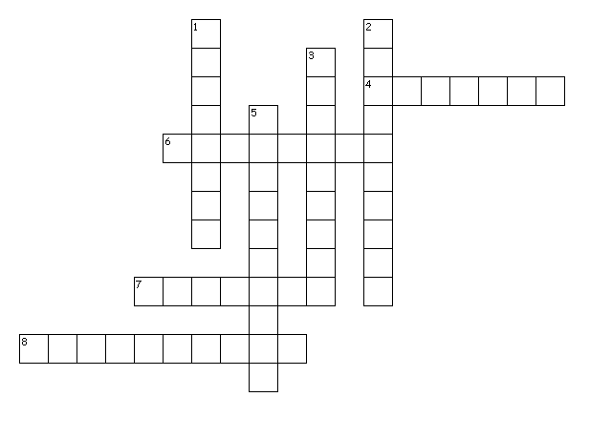
Across
4. wagon wheel shape pasta
6. thick hollow spaghetti
7. a single s shaped strand of pasta
8. small bow tie shapes
Down
1. flattened pasta
2. thicker than spaghetti
3. large stuffable pasta
5. larger bow ties

