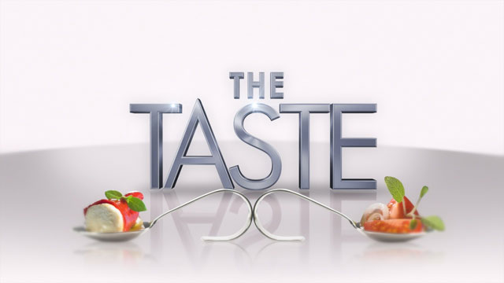
Requirements:
- Dish is “Asian” in nature
- You can make 1 full portion – what is submitted is just a “taste” (4 portions of taste for judging)
  - The rest is to be eaten by your group
  - Must be a planned meal
    - Would you have some of these ingredients in the house – what?
    - What would you need to buy from the store – what portions would you buy in and why?
  - Submit grocery list
    - Do not need to submit recipe
- Plan out portion sizes of ingredients for each “taste”
- Dish must include 1 meat/alternative (protein)
- Dish must include at least 2 fruits/veggies (carbohydrates)
- Dish must include 1 milk/dairy/alternative (fat)
Timeline:
- Wednesday April 16 – computers – research day
- Tuesday April 22 – prep day – prep ingredients – last minute research/planning
- Thursday April 24 – challenge – submit tastes for judging
- Marks for:
- Creativity
- Visual – plating (on spoon)
- Taste
- Includes all requirements
- All team mates are involved

Marking:
 | Aspects to be met | Comments
Asian Theme | Knows country of origin or fusion countries  Is noticeably Asian
Serving Sizes | Is one mouthful  Each “taste” looks the same  Each “taste” has all ingredients  What is left is only part of 1 serving
Overall Appearance | Looks nice, good, beautiful, could be sold  Colourful  Not burnt or soggy  Fits on the spoon/taste
Overall Taste | Has good flavour  Has good texture
Includes All Required Ingredients | Contains 1 meat, 2 fruits or veggies and 1 dairy
Fulfilled All Project Requirements | Submit planning aspects  Plan is done well – complete  Submit grocery list
Teamwork | Each person in group has a role  Have good time management  On task

