Thai Coconut Curry Soup
Recipe
Ingredients:
- 125ml rice
- 1 chicken breast
- ½ onion, diced
- 2 cloves garlic, minced
- 30ml coconut oil
- 1 carrot
- 1 (14oz) can coconut milk
- 250ml chicken broth
- 15ml curry powder
- 5ml garam masala
- 5ml lime juice
- Salt and pepper to taste
Method:
- Add rice and equal parts water into a small pot. Bring to a boil, cover, reduce heat and simmer for about 10 minutes.
- Dice chicken breast. Put into a frying pan with 15ml coconut oil and sauté until golden.
- In large soup pot combine 15ml coconut oil with garlic and onion. Cook on medium heat until fragrant. About 3-5 minutes.
- Add spices and lime juice.
- Shred carrot with veggie peeler. Add to soup pot. Add can of coconut milk and chicken broth.
- Bring to a slight boil then reduce to simmer. Add cooked rice and chicken.
- Sprinkle sliced green onions or bean sprouts on top to serve.

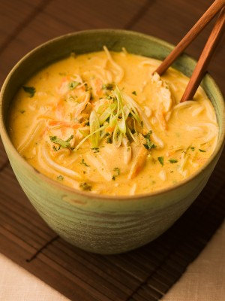

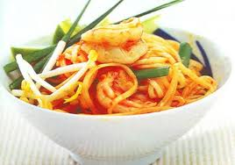
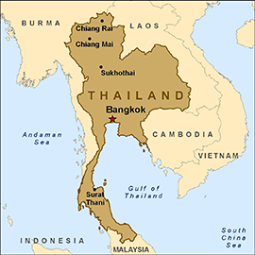

Print image from this map: https://maps.google.ca/maps?q=thai+food&safe=off&hl=en&ie=UTF8&hq=thai+food&hnear=New+Westminster,+Greater+Vancouver,+British+Columbia&t=m&vpsrc=6&fll=49.147356,-122.88311&fspn=0.065687,0.169086&st=100083498510612611957&rq=1&ev=zi&split=1&ll=49.140281,-122.871094&spn=0.065697,0.169086&z=13&ei=2Xd8Ut3qKsyyiAKV6IDgBA&pw=2
Thai restaurants near by:
- Closest: One more Thai on scot road and 72nd.
- 2nd: Sandars Thai Garden Restaurant a bit further up scot road
- And 3rd: thai by tahi just on the other side of 88th

Fun facts:
- Rice = the most popular food in the world
Safety:
- With knife
- With peeler
- With cooking chicken

Tips for your presentation:
- Have something written down so you don’t have to memorize everything
- Speak loud and clear, don’t go too fast
- Focus on what you are doing first – there are 2 of you so be safe with what you are doing, other person not cooking can talk if that is an issue
- Share roles
- You don’t need to be talking all the time – ask questions, get volunteers, silence is okay sometimes too but keep us interested

