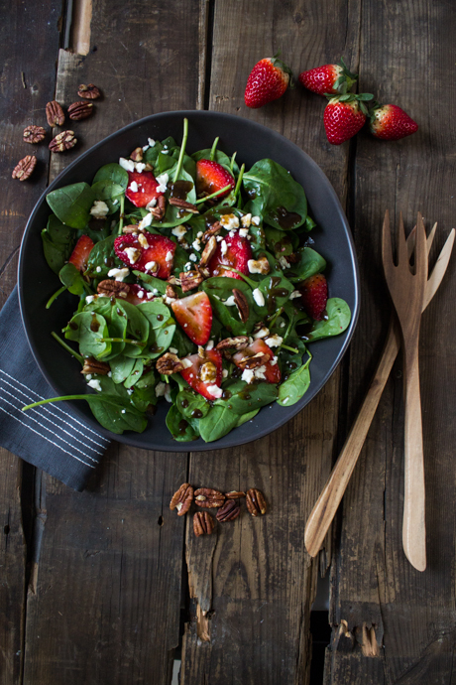
Strawberry Spinach Salad
Ingredients:
For the Salad:
- 2 handfuls fresh baby spinach
- 4 sliced strawberries
- Handful toasted pecans (could sub for almonds)
- 25ml feta cheese, crumbled (could sub for goat cheese)

For the Dressing:
- 10ml balsamic vinegar
- 2ml brown sugar
- 1 garlic clove, minced
- Pinch of salt
- Pinch of pepper
- 30ml olive oil

Directions:
- First prepare the dressing
  - In a bowl, whisk together the vinegar, sugar, salt an pepper until the sugar has dissolved
  - Mince the garlic almost into a paste, and add
  - Add the oil
  - Let sit until salad is complete
- Second prepare the salad
  - Toast pecans in oven for 3-5 minutes – until aromatic
  - Wash and dry spinach
  - Wash, remove stem and slice strawberries
  - Toss spinach with strawberries and toasted pecans
  - Crumble feta on top
- Add dressing to salad and serve immediately

Greek Salad
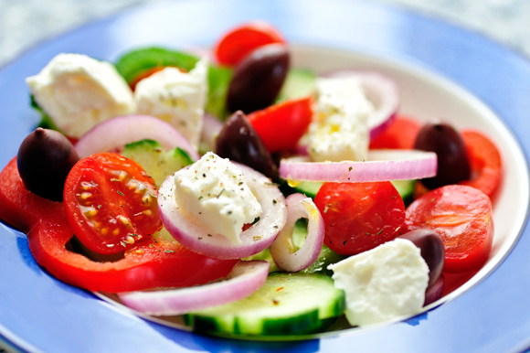
Ingredients:
For the Salad
- 1 Roma tomato
- ¼ of a cucumber
- 1/6 of an onion
- ¼ of a green bell pepper
- 25ml pitted black olive
- 25ml feta cheese
For the Dressing:
- 30ml olive oil
- 10ml lemon juice
- 1 clove garlic
- 2ml red wine vinegar
- 1ml dried oregano
- 1ml dill weed
- Salt and pepper to taste

Directions:
- Whisk together olive oil, lemon juice, vinegar, oregano and dill
- Mince garlic and add
- Season to taste with salt and pepper
- Let stand until salad is done – whisk before adding to salad
- Chop the tomatoes coarse
- Chop the cucumber coarse
- Slice the onion
- Chop the bell pepper coarse
- Chop the olives coarse
- Toss in a large bowl
- Toss with dressing and crumble feta cheese on top
- Serve immediately

