Stir Fry
Ingredients:
- ½ cup rice
- 10ml canola oil
- ½ carrot
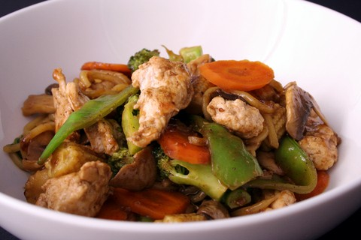
- ¼ bell pepper
- 1/6 of an onion
- Piece of broccoli
- 1 clove garlic
- Portion of bok choy
- Pinch of salt and pepper
- ½ of chicken breast
- Sauce:
  - 40ml soy sauce
  - 30ml chicken broth
  - 20ml rice vinegar
  - 10ml sugar
  - 4ml sesame oil
  - 5ml minced ginger
  - 5ml cornstarch

Method:
- Measure 1 and half cups of water into a small pot, add rice and bring to boil
- Reduce heat to low and cover with lid – until water is all gone and rice is tender (about 15minutes)
- Prep sauce by whisking ingredients together in small bowl
- Prep all ingredients before starting cooking
- Mince garlic, slice carrot, bell pepper, onion, cut off broccoli florets and slice the stems, chop bok choy
- In a large skillet heat canola oil on medium-high
- Add meat and cook for a minute until colour change
- Add peppers, onion, broccoli, carrot and garlic – stir constantly – cook about 2 minutes
- Add the bok choy, salt and pepper – stir another minute
- Plate your rice, add stir fry on top, top with sauce – enjoy!

