Miso Soup
(Yields: 2 bowls)

Ingredients:
- 3oz block of firm silken tofu
- 500ml dashi
- 25ml dark or red miso
- 7ml light or white miso
- 1 scallion, thinly sliced

Directions:
- Wrap the tofu in 2 layers of paper towel and lay on a plate. Invert a second plate on top and weigh down. Let sit for 10 minutes.
- Heat the dashi in a saucepan over medium high heat.
- Once it is simmering, remove 1 cup of the dashi into a measuring cup and add miso. Whisk until smooth.
- Bring remaining dashi to a simmer, about 10 minutes. Add the miso mixture and whisk to combine. Return to a simmer but do not bring to a boil.
- Add the tofu and scallions. Cook for another minute until heated through.
- Remove from heat, ladle into bowls and serve immediately.
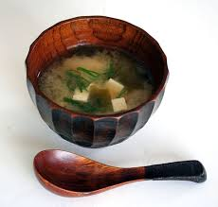
Dashi Recipe
(makes enough for miso soup recipe above)

Ingredients:
- ½ of 1 (4 inch) square piece of kombu
- 700ml water
- 125ml bonito flakes or katsuobushi

Directions:
- Put the kombu into a saucepan and cover with the water.
- Soak for 15-30 minutes.
- Set the saucepan to medium heat until bubbles start to form around the sides. (about 9-10 minutes)
- Remove the kombu from the pan. Increase the heat to high and bring to a boil. (5-6 minutes)
- Reduce the heat to low and add the bonito flakes. Simmer gently for 10 minutes, stirring frequently.
- Strain the liquid through cheesecloth lined strainer.
- Store in an airtight container in the refrigerator. Use within 1 week or freeze for up to a month.

