Mini Quiche Tartlets
(Yields: 8 servings)
Step #1: The Pastry
Ingredients:
- 60ml unsalted butter
- 1ml salt
- 5ml sugar
- 185ml flour
- 30ml sour cream
Directions:
- Preheat oven to 350 degrees F
- Mix dry ingredients together in a medium sized bowl
- Cut in cold butter until pea sized crumbs
- Add sour cream and mix with a fork until dough comes together
- Pat dough into a ball and let rest 5 minutes in the fridge
- On a lightly floured surface roll out the dough somewhere between 1/8-1/4 inch thick
- Cut out tartlets with a cookie cutter
- Lightly grease muffin tin, push tartlets into the cups
- Prick the bottom with a fork and bake for 5 minutes – they will not be done but will be more likely to cook all the way through when you add the filling
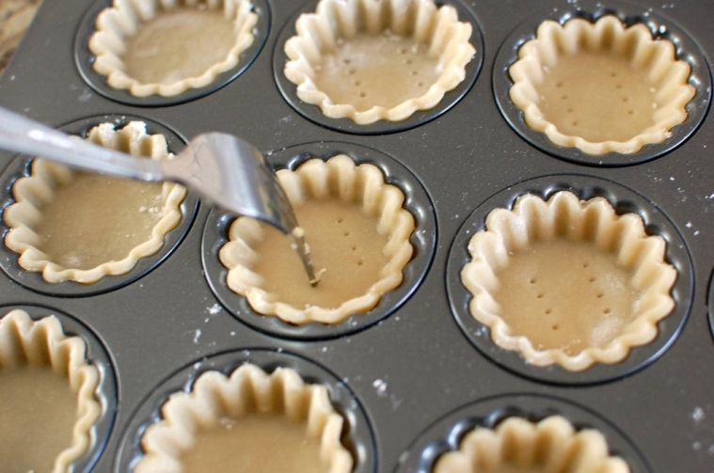

Step #2: The Filling
Ingredients:
- Half package of cream cheese (4oz)
- 25ml milk
- 2 eggs
- Half cup of cheese
- 1/6 of a green pepper, diced small
- 1/8 of an onion, diced small
- 2 bacon strips

Directions:
- When the tart shells come out of the oven increase the temperature to 375 degrees F
- Cook bacon in a frying pan – once cooked and cooled chop finely
- In a small bowl beat together cream cheese and milk until smooth
- Whip in the eggs
- Add the cheese, green pepper and onion - mix well
- Sprinkle half of the bacon into the prebaked tartlets
- Pour egg mixture over top of bacon, sprinkle with remaining bacon
- Bake for 18-22 minutes or until a tester comes out clean

