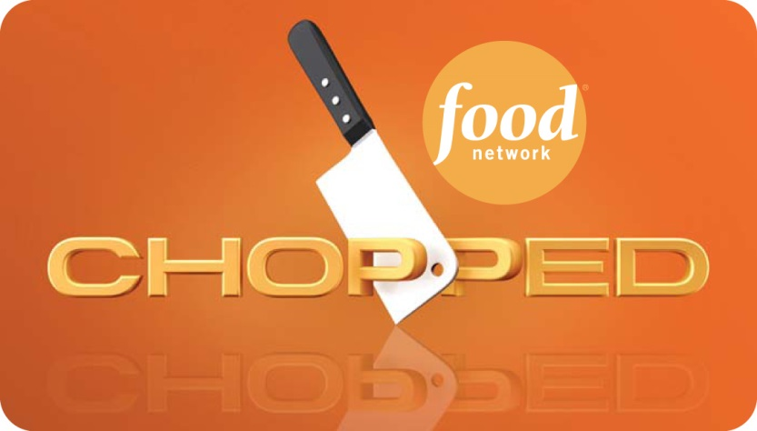

Grade 9 Chopped Challenge
The Task – Your groups have been tasked with making two dishes in two class periods. A main course and a dessert. You will have 45 minutes to prepare the main course on the first day. Then judging will ensure. The same procedure will go for the dessert on day two.
Prior to the Chopped Challenge you will be given research time to prepare yourselves with how to cook the items you do know you have, as well prepare your pantry of additional items you may need to make a delicious dish. For the dessert you can plan on making any dish that can be completed in the time frame, just be sure you are able to incorporate the secret ingredients you will be given.
Secret Ingredients – As in all chopped challenges there will be a mystery basket. In that basket you are aware of the following ingredients:
Main Course:
SPAGHETTI NOODLES
GROUND BEEF (or tofu product)
TOMATO PASTE
There are also TWO secret ingredients you do NOT know about for the main course. These will vary due to 4 different choices. We will draw knives to decide who gets which ingredients.
For the dessert you know that you will be receiving a FRUIT and a SWEET item, but not what it is.

Judging – Your dishes will be judged on the following:
PRESENTATION TASTE CREATIVITY
Judges will be invited in during this block – can include other teachers, students, and other school staff. If you have a parents/guardian you would like to judge they can also come in during the class.
Judging Day 1: Main Course – Wednesday December 4th
Judging Day 2: Dessert – Friday December 6th
Rubric:
 | Exceeding Expectations | Meeting Expectations | Nearing Expectations | Not Yet Meeting Expectations
Preparation |  | Utilizes research time  Finds recipes for main and dessert including the ingredients and method | Does not include all necessary items | Does not include most necessary items
Time Management |  | Completes dishes with adequate time to plate and present  Completes clean up in class time | Needs a few reminders on timing | Needs lots of reminders  Does not complete dish or clean up on time
Teamwork | Group works flawlessly  Everyone always on task | Each person in group has a role and is participating | Tasks are not divided evenly, not everyone has a role | Team does not function well together
Main Dish | Tastes amazing  Presented beautifully  Very creative | Tastes good  Looks nice  Is somewhat creative | Missing 1 of the 3 criteria | Missing 2 or more of the criteria
Dessert | Tastes amazing  Presented beautifully  Very creative | Tastes good  Looks nice  Is somewhat creative | Missing 1 of the 3 criteria | Missing 2 or more of the criteria
Secret Ingredients | Uses both in a unique way so they enhance the dish | Uses both in main and dessert  Makes them taste good | Only uses one in main and dessert  Don’t utilize them well | Does not use secret ingredients  Adds them in a way that they taste bad

