Name: ___________________

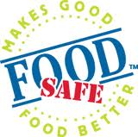
FoodSafe Level 1
Why take it? To learn how to work safely to prevent foodborne illness.
The purpose of FoodSafe is to:
- Create awareness of foodborne illness and worker injury
- Reduce the possibility of food related illness
- Share the importance of safe work habits in the food industry

Introduction to FoodSafe
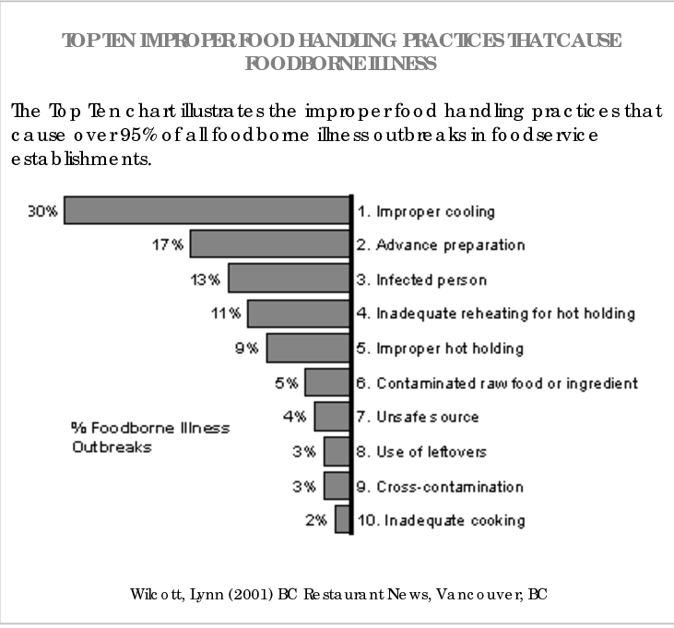
Top 10 Improper Food Handling Practices

What are the most common injuries?

- _____________________________________
- _____________________________________
- _____________________________________
- _____________________________________

What are the 3 things that you do to minimize risk.

____________________ _____________________ _____________________
What are 2 of the responsibilities of....
- Workers:
  - 1. _________________________________________________________________________
  - 2. _________________________________________________________________________
- Employers
  - 1. _________________________________________________________________________
  - 2. _________________________________________________________________________

Topic 2: Foodservice Illness & Injury
What are microbes?

What are the 5 different kinds of microbes?

- ________________________
- ________________________
- ________________________
- ________________________
- ________________________

What are the 3 parts of the cycle of transmission? (Give 1 example of each)
- ______________________________________________________________________________
- ______________________________________________________________________________
- ______________________________________________________________________________
Which is the most important? Why?
____________________________________________________________________________________________________________________________________________________________________________________________________________________________________
What’s an example of a chemical cause of foodborne illness?
_________________________________________________________________________________________________________________
What’s an example of a physical cause of foodborne illness?
_________________________________________________________________________________________________________________
What is the time for safety margin of bacterial growth?
__________________
What does that mean?
______________________________________________________________________________________________________________________________________________________________________________________________________________________________________________________________________________________________________________________________________________________
What is the danger zone?
__________________________________________________________________________________
What does FATTOM stand for? Give an example of what is most dangerous.
F: ______________
__________________________________________________________________________________________________________________
A: ______________
__________________________________________________________________________________________________________________
T: ______________
__________________________________________________________________________________________________________________
T: ______________
_________________________________________________________________________________________________________________
O: _______________
__________________________________________________________________________________________________________________
M: _______________
_________________________________________________________________________________________________________________

Controlling Sources of Food Contamination:
What does “potable” water mean?
_______________________________________________________________________________________________________________
Give 3 examples of what you can do to prevent food contamination in the class:
- ______________________________________________________________________________________________________
- ______________________________________________________________________________________________________
- ______________________________________________________________________________________________________
How should you thaw or defrost frozen food?
____________________________________________________________________________________________________________________________________________________________________________________________________________________________________
How many times can you reheat an item of food?
_______________________

