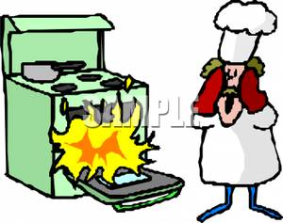
Foods Safety!

OVEN
- Hot – could burn you
- Use oven mitts or pot holder – NEVER use a towel and ESPECIALLY never use a wet towel
- To use – open the door ALL THE WAY and pull out the rack PART WAY – put food onto rack – push rack in then close the oven

STOVE
- Hot – could burn you
- Put pots and pans onto elements – have handles pointing INWARDS so you don’t bump them

FIRE
- On stove top – turn off element
- Smother flames using the lid
- If it is an oil/fat fire you can use salt or baking soda to smother the flames do NOT use water or flour – they will explode at you

BURNS
- Rinse under cool water
- Alert the teacher
- Steam burn – DON’T put hand over open steam (from kettle or pot)
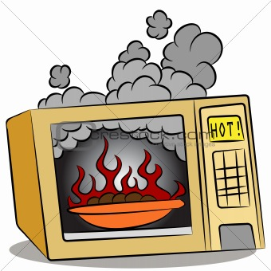
APPLIANCES
- Unplug using the PLUG do NOT pull on the chord
- Watch for frayed chords and alert teacher
- Microwave
- NEVER put aluminum foil or metal objects in the microwave

KNIVES
- Walk like how you do with shears in textiles
  - Knife point facing down, go slow
- When cutting pay attention to what you are doing
- Don’t put into a sink of water – dishwasher needs to know what is in the sink – leave on counter and they can do the dish when ready

CUTS
- Rinse under cool water
- Apply pressure and raise the wound
- Alert the teacher and get a bandaid

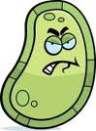
GERMS
- Clean everything properly – hands/dishes/food
- Use hot soapy water
- Wash for at least 20 seconds or the length of happy birthday
- Don’t cross-contaminate by washing knives/cutting boards between uses
- Don’t be touching your face/hair a lot while cooking
- Sneeze/cough into elbow!

SPILLS
- Clean it up IMMEDIATELY – use towels
- Alert others to spills
- Avoid spilling by going slow, don’t fill water to brim, don’t put items filled with liquid close to the edge of tables

CHOKING
- CHEW YOUR FOOD
- Take small bites
- Tell the teacher immediately if someone is choking

PEOPLE
- Can be distracting
- Pay attention to what you are doing
- Be careful when walking with heavy, hot or sharp objects
- No music, no shoving, put backpacks under table
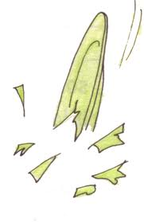
BROKEN DISHES
- Use a broom and dustpan to collect large pieces – then use damp PAPER TOWEL to collect little splinters
- Why not a cloth – could get caught in cloth and cut you later – paper towel gets thrown out
- Be careful carrying dishes and putting dishes into the sink

ATTIRE
- Hair tied back
- Apron on
- No loose clothes – sleeves pushed up

HOW TO ACT DURING EARTHQUAKE/FIRE DRILLS
- Stay calm
- Turn off all stoves/ovens
- Close all doors and windows when leaving room
- Unplug all electrical equipment
- Stay together

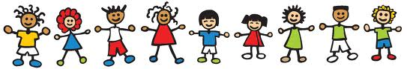
Then we can be a happy and safe class.

