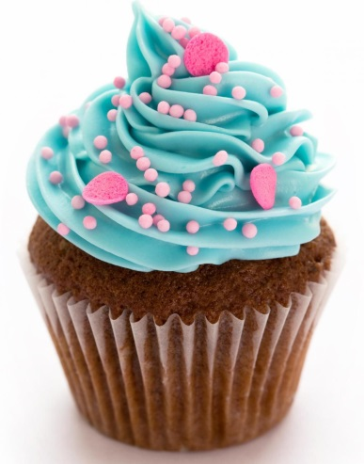

Mmmm… Cupcakes!
(Yields 6 cupcakes – must choose one or the other!)
Option #1:  Vanilla Cupcake | Option #2:  Chocolate Cupcake
180ml all-purpose flour  2ml baking powder  Pinch of salt  45ml butter  90ml sugar  1 egg  2ml vanilla  75ml milk | 170ml all-purpose flour  2ml baking powder  Pinch of salt  45ml butter  90ml sugar  1 egg  2ml vanilla  75ml milk  15ml cocoa powder

Method:
- Preheat oven to 350 degrees
- Line muffin tins with cupcake liners and set aside
- In a medium bowl mix together dry ingredients (EXCEPT SUGAR)
- In a large bowl, cream together butter and sugar until light and fluffy – add egg and beat in vanilla
- Add flour and milk alternately, ending with flour
- Divide batter among liners – should be about ¾ full
- Bake until tops spring bake when touched – about 20 minutes – transfer to a wire rack and let cool

**If you would like to frost your cupcakes they need to cool completely before doing so (otherwise frosting will melt off). Wrap cupcakes in saran wrap and store in back of class for next day if you wish to frost.

