Chocolate Oatmeal Chip Cookies

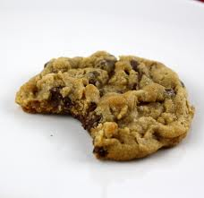
Ingredients:
Cookies:
- 60ml margarine
- 60ml white sugar
- 60ml brown sugar
- 1 egg
- 2ml vanilla
- 60ml rolled oats
- 175ml all-purpose flour
- 1ml baking soda
- Pinch of salt

Method:
- Preheat the oven to 350 degrees F
- Cream together the margarine and the sugar
- Add the egg and vanilla, mix well
- In a separate bowl, mix the flour, baking soda and salt
- Add the dry ingredients to wet ingredients, mix well
- Add the oats and chocolate chips – mix well
- Shape dough into equal sized balls

- Place on a cookie sheet approximately 2 inches apart – do NOT flatten
- Bake for 10-12 minutes, or until edges are golden

