Buffalo Wings
Ingredients:
- 2 wings per person
- 1/6 of an onion, chopped
- 1 garlic clove, minced
- 1/6 of a pepper, chopped
- 25ml brown sugar
- 10ml soy sauce
- 5-10ml hot sauce

Fry Method:
- Bring pot of water to boil – boil wings for 8 minutes then put in fridge
- Fill cast iron frying pan with oil (will be shared between units)
- In small pot combine chopped onion, garlic and pepper cook for 1-2 minutes
- Add brown sugar, soy sauce, hot sauce, salt and pepper cook for 5-10 minutes until veggies are soft
- Pour sauce into a blender and mix on high until smooth
- Dry off wings thoroughly
- Heat oil, add wings with slotted spoon – cook for 2-3minutes per side
- Remove wings with slotted spoon and put onto paper towel
- Immediately toss in bowl of sauce

Oven Baked Method:
- Preheat oven to 425 degrees F
- Make sauce
- Toss wings in sauce
- Bake for 15 minutes then turn wings and drizzle more sauce over wings
- Bake for 15 minutes more
- Remove from oven

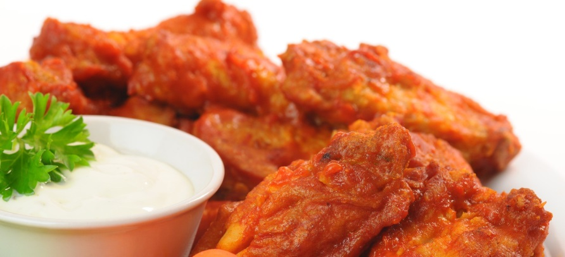

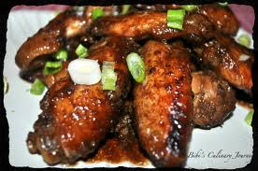
Honey Garlic Wings

Ingredients:
- 2 wings per person
- 25ml soy sauce
- 40ml honey
- 2 garlic cloves, minced
- 1ml sesame oil
- Dash of cayenne
- Salt and pepper

Fry Method:
- Bring pot of water to boil – boil wings for 8 minutes then put in fridge
- Fill cast iron frying pan with oil (will be shared between units)
- In small pot combine soy sauce, honey, minced garlic, sesame oil, cayenne, salt and pepper, cook for 5 minutes, stirring constantly
- Dry off wings thoroughly
- Heat oil, add wings with slotted spoon – cook for 2-3minutes per side
- Remove wings with slotted spoon and put onto paper towel
- Immediately toss in bowl of sauce

Oven Baked Method:
- Preheat oven to 425 degrees F
- Make sauce
- Toss wings in sauce
- Bake for 15 minutes then turn wings and drizzle remaining sauce over wings
- Bake for 15 minutes more
- Remove from oven

