Cheese & Potato Omelette
Serves 2

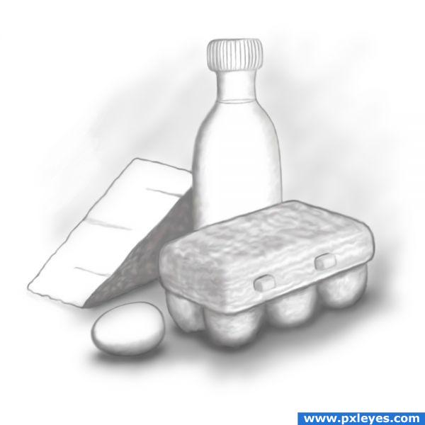
INGREDIENTS:
1 small potato
5mL oil
0.5mL salt & pepper
60mL cheese
2 green onions
3 large eggs
10mL milk
Margarine to grease pan

DIRECTIONS:
- Peel and grate potato. Rinse grated potato in cold water until water does not look cloudy (removes starch to prevent stickiness). Blot dry with paper towel.
- Heat 5mL oil over medium heat in a small frying pan. Add grated potato, salt and pepper. Cook on medium heat until browned and soft. Remove the cooked potato and set aside.
- Grate cheese. Wash and chop green onion.
- Whisk eggs and milk with a pinch of salt and pepper.
- Heat frying pan again for omelette on medium heat. Lightly grease pan with 1mL margarine before each omelette.
- Arrange HALF of cooked potato over frying pan. Pour HALF of egg mixture over potato. Swirl pan to cover the entire bottom with egg, cover pan and cook for 2-3 minutes.
- Check that egg has COAGULATED. Add cheese, green onions and fold omelette closed. Cook 1-2 more minutes or until cheese has melted.
- Repeat with 2nd or 3rd omelettes.

SET TABLE

