Cake Project
Goal: in half units you are going to create a three tiered cake OR
a shaped cake of your choice
Cake Requirements:
- You must have a theme to your cake
- The cake must be three tiered or shaped
- You must submit a drawing or sketch of what your cake will look like and what the parts will be made of
- You must provide your own cake recipe
- You must provide your own icing recipe
- You must use fondant on the cake in some way
- You must have decorations on the cake and they must be edible
- You must provide a list of what you need in order to make decorations
- You must use colour on your cake
- Each person in your group must have a role
- You must provide a small tasting section aside from your real cake for Ms Miller to taste

Timeline:
- March 31 – cake recipe, icing recipe, cake design, plan
- April 2 – fondant making and shaping practice
- April 4 – day off – group project
- April 8 – episode of a cake show from television, last minute ideas and planning
- April 10 – make icing and practice piping
- April 15 – bake cakes and prepare advanced decorations
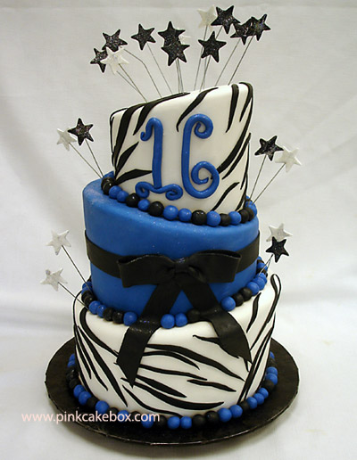
- April 17 – finish cakes and judging
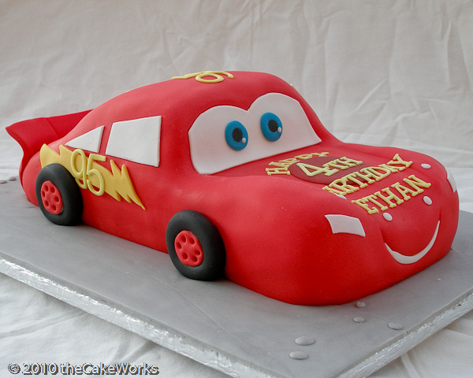
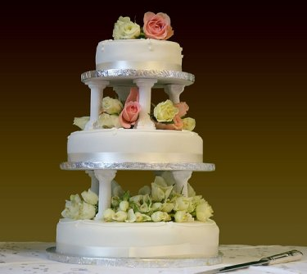
Marking:
 | Aspects to be met | Comments
Theme | Has a noticeable theme
Cake | Provides recipe  Is a three tier or shaped cake  Is cooked well  Has a good flavour
Icing | Has a good texture  Has a good flavour
Fondant | Has a good texture  Has a good flavour  Has no cracks or flaws
Decorations | Has decorations  - None  - 1-3  - 4-7  - 8-10  - 11+  Decorations look beginner, intermediate, advanced
Colour | Creates desired/planned colours  Uses appealing colours
Overall Appearance | Looks okay, nice, beautiful, could be sold  Theme goes together nicely  Stands as a cake (is together, not falling apart)
Overall Taste | Everything has good flavour and works together  Cake is moist
Teamwork | Each person in group has a role  Have good time management  On task

