Butternut Squash Ravioli
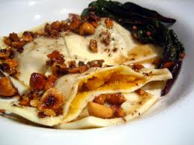
The Dough
250ml 1 cup all-purpose flour
3 medium sized eggs
2ml ½ tsp olive oil
Pinch of salt

Clean countertops. Pile flour onto counter. Make a well into the center. Crack eggs into the well. Add olive oil and salt to the eggs. Whisk eggs gently with a fork. Start kneading directly on counter.
If dough is crumbly add small amounts of water so it comes together in one mass. Once it is a uniform blob knead dough for 10 minutes or until it is shiny and elastic. Test with finger poke.

Ravioli Filling:
1/6 of a 2lb butternut squash, cooked and mashed
¼ of a medium sized onion, chopped fine
2ml ½ tsp ground sage
5ml 1 tsp butter
1 garlic clove, minced
30ml 2 Tbsp ricotta
10ml 2 tsp parmesan
Salt and pepper to taste
Preheat oven to 400 degrees F. Cut squash in half and remove seeds. Place cut side down onto a baking tray. Bake for 50 minutes or until squash pierces easily with a fork.
In a small bowl combine chopped onion, ground sage, butter, minced garlic, ricotta, parmesan and salt and pepper.
Once squash is out of the oven and cool enough to handle remove from skin and mash with a fork into the other filling. Mix well.
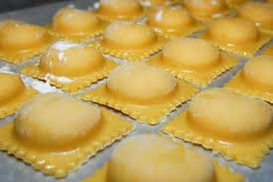
Sauce:
50ml ¼ cup butter
15ml 1 Tbsp toasted pecans, chopped
1ml ¼ tsp sage
5ml 1 tsp lemon juice
30ml 2 Tbsp tomato paste
30ml 2 Tbsp heavy cream
Salt and pepper to taste
Heat butter until foamy, mix constantly so butter doesn’t burn. Add sage. Cook until butter is deep golden. Add lemon juice (butter will foam) then remove from heat. Whisk in tomato paste and cream. Season with salt and pepper to taste.

Putting it together:
Separate dough into 2 even parts. With a rolling pin or pasta roller flatten dough into long rectangular shapes about 2-3mm thick.
Place filling into equal sized blobs around 1-2 inches apart from each other along one of the sheets of pasta.
Brush a small amount of water around the circumference of each pile of filling. Then place the other sheet of pasta on top, pressing down around each filled ravioli.
Using a pizza roller or a knife cut around each pile of filling. Press down around edges with a fork ensuring a seal.
Reroll and fill any extra dough.

Cooking the Ravioli:
As you are filling your pasta get a large pot of water boiling with a bit of salt added. Once ravioli is made put them into the pot of boiling water. They should sink. Ravioli is done when they float, about 5-10 minutes depending on size.

