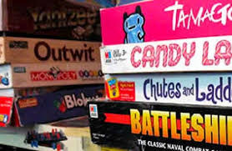
Board Game Project

Why: This board game is to be used as a final assessment (INSTEAD OF A BIG TEST, I MIGHT ADD!) to what you learned this year.
How: You can do this in groups or alone. Keep in mind that there needs to be enough for each person to do each day. You will be given lots of class time to create the game and play each other’s games.
When: (fill in dates so you know when to bring supplies)
_________________________
_________________________
_________________________
Must include:
- Information/questions from one or more of the units we covered this year
- Be a board game in nature – can be similar to any board game (monopoly, cranium, battleship, Pictionary, etc) or completely made up
- Must have rules of the game including,
  - Number of players
  - Objective of the game – what are you trying to do
  - How do you start – oldest player, roll dice, etc…
  - How do you end/find winner– time limit, end point, score, etc…
  - How much is based on luck, how much on skill – free squares, move ahead, answer question, etc…
- Must be colourful and decorated
- YOU Must be able to explain and get a group of students to play

Sample Timeline:
Day 1: Come up with a game idea, what unit(s) you want to cover. And start coming up with questions. And name your game.
Day 2: Create a template of board game and ideas of how to decorate (consider the path it will take, the size, etc). Plan who will bring supplies to make the actual game next class. Come up with rules of play (consider, will you need dice, buzzer, timer, game pieces, cards). Test game by playing it.
Day 3: Make the good copy of the game and rules. With all the artistic elements.
Following class one person per group will stay at their game to teach a group of students who to play and run the game. Everyone else will move around the room sampling the different game choices.

