Basic Measures and Techniques
Abbreviations:
Word: | Abbreviation: | Word: | Abbreviation:
Few Grains |  | Few Drops
Millilitre |  | Litre
Gram |  | Kilogram
Hour |  | Minute
Tablespoon |  | Teaspoon
Cup

Measuring Utensils in the Lab:
Liquid Measure: Dry Measures:
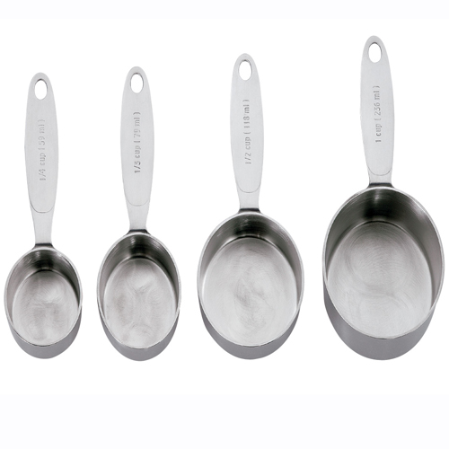
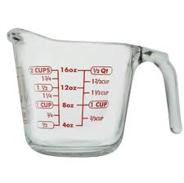
Cups:

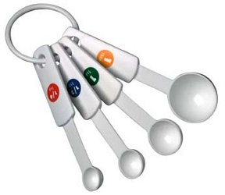
____mL _____mL _____mL ____mL
____cup _____cup _____cup ____cup

Spoons:
**For small dry or liquid measures
______mL = _______ tsp. ____mL = ______tsp.
______mL = _______ tsp. ____mL = ______Tbsp.

Size of Measures:

If you were measuring with dry and small measures, how would you measure the following amounts?
Example: 375mL of flour = one 250mL measure and one 125mL measure
- 750mL of rolled oats _________________________________________________
- 200mL sugar _______________________________________________________
- 175mL brown sugar _________________________________________________
- 336mL wheat germ __________________________________________________
- 65mL whole wheat flour ______________________________________________
- 275mL flour _______________________________________________________
- 136mL sunflower seeds ______________________________________________
- 3mL salt __________________________________________________________
- 8mL baking powder _________________________________________________
- 40mL sugar _______________________________________________________

Measuring Techniques:
Explain how you would measure the following ingredients. Include which measures you would use (ex. Dry or liquid) the sizes of the measures, and the specific method you would use (packing, sift, level, etc)
- 150mL all-purpose flour ________________________________________________________________________________________________________________________________________________
- 335mL white sugar ________________________________________________________________________________________________________________________________________________
- 135mL brown sugar ________________________________________________________________________________________________________________________________________________
- 150mL water ________________________________________________________________________________________________________________________________________________

