Bannock
(Serves 2-3)
Is a staple of First Nations foods and has many variations

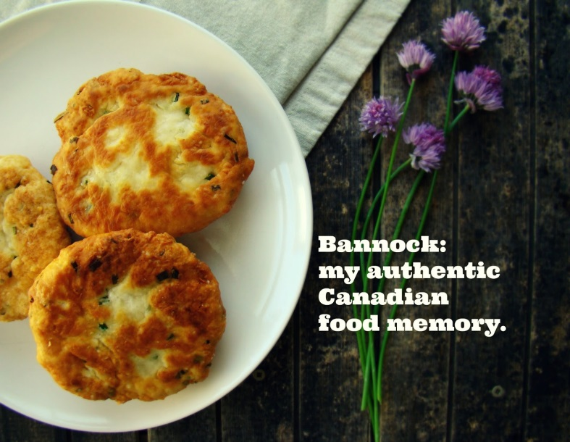
Ingredients:
- 1 cup (250ml) flour
- 1 tablespoon (15ml) sugar
- 1 teaspoon (5ml) baking powder
- ¼ teaspoon (1ml) salt
- ½ cup (125ml) cold water
- Oil for frying
Coating:
- 1 tablespoon (15ml) sugar
- 1 teaspoon (5ml) cinnamon

Method:
- Mix all ingredients together and cover for 10-20 minutes with a towel – the longer it sits the fluffier it will be
- As the dough sits, heat up some oil for shallow frying – use a cast iron pan with about an inch of oil
- Heat on medium-high temperature
- Divide dough into even pieces (about 3-4) and pat the dough out into hand size
- Place dough CAREFULLY into the oil – lower with tongs then remove
- Fry one side for 1-4 minutes until it is a golden brown then flip the bannock with tongs and fry the other side
- As soon as bannock comes out of the pan drain on paper towel then toss with cinnamon and sugar

